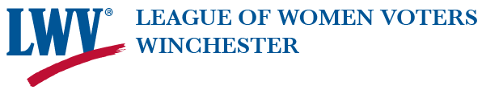

Please join us as we present
The
2022 Civic Leadership Award
to
Susan Verdicchio

Saturday, June 11th

At 10:30 a.m.

- Annual Meeting will immediately follow the award ceremony.
- Zoom ceremony link to be sent a few days before Annual Meeting.
- Inquiries may be sent to award@lwvwinchester.com by June 9th.

